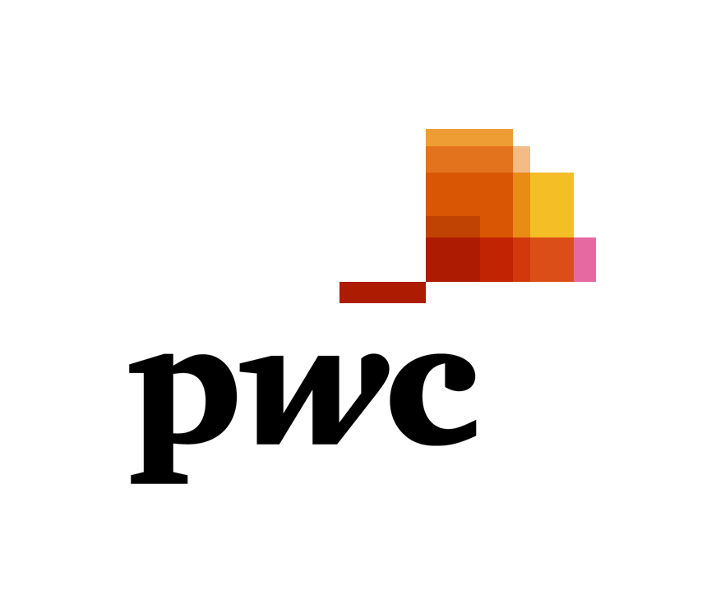

Junior Tax Consultant
Are you looking for great career opportunities in the leading professional services company?
Join us as Junior Tax Consultant and you will quickly get your hands on some exciting work and develop an in-depth understanding of our clients’ businesses and industries.
We are looking for:
- Fresh graduates, Master graduates/ students and young professionals (economic field);
- Interest in taxation and a high level of business awareness;
- Ability to work in a team environment and a hardworking approach;
- Extensive computer skills (MS Word, Excel, Internet);
- Excellent working knowledge of the English, Romanian, Russian languages;
- Motivation for professional development and a genuine desire to develop skills;
- Excellent communication and interpersonal skills;
- Previous experience in that area would be considered an advantage;
- Availability to travel.
How to apply. Please apply no later than 12 April 2019 at: olga.turculet@pwc.com

