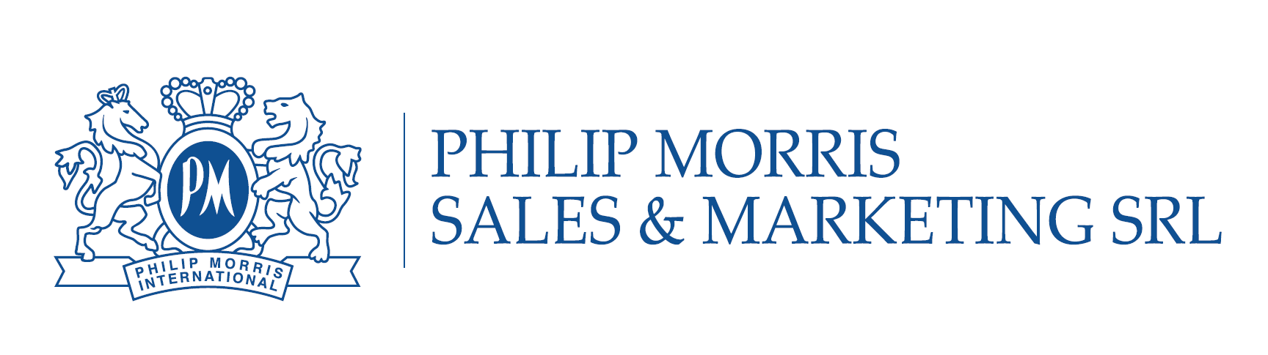
Manager Commercial Intelligence and Planning
IF YOU HAVE:

- High education
- Analytical skills and logical thinking
- Upper-Intermediate+ level of English
- 4+ years' experience in analytics, forecasting, market intelligence, planning, sales and distribution management
- 3+ years of experience in managing teams
- Advanced knowledge of Project management methodologies
- Advanced level in MS Office

You are the one we want to meet for staffing our Commercial team in Philip Morris Moldova, based in Chisinau, Moldova

YOU WILL:

- Build and manage a team of professionals, provide and inspire constructive collaboration among the Team members
- Lead analysis and interpretation of market intelligence data for long and short term planning of activities projects
- Develop specific brand and trade channel initiatives to contribute to national commercial strategy
- Development Plan (commercial initiatives, channels' infrastructure and Territory specific brand consumer activation programs) in accordance with overall Strategy
- Maintain and develop comprehensive knowledge of business environment, consumer segmentation and trends, competitors, trade partners and market trends within the area of responsibility in order to establish full understanding of business context
- Monitor focused and cost-effective utilization of the allocated resources to support Commercial activities
- Regularly track the effectiveness of deployed activities and develop action plan to deliver sustainable business results in the area of responsibility

WHAT WE OFFER:

- You will get unique development opportunities
- You will enjoy building your network among highly professional colleagues
- You will get competitive level of compensation & social package
- You will work in truly international environment

To apply for the job, please send your CV to recruitment.moldova@pmi.com
Only shortlisted candidates will be contacted

