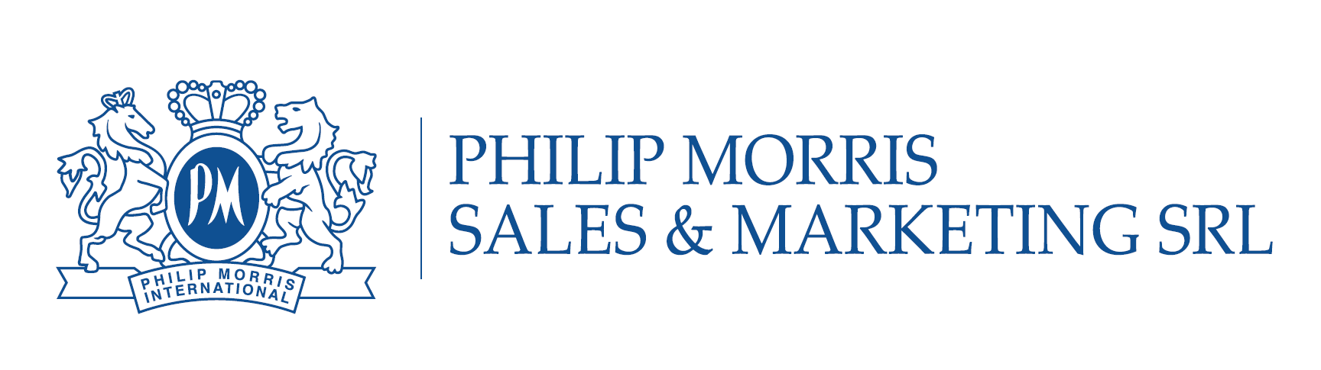
RRP DEPLOYMENT EXECUTIVE
Are you results driven, have strong communication skills and high learning agility?
We are looking for a collaborative person with strong customer focus, who is capable to work in consistent ambiguity in the area of providing partnership service related to RRP products commercialization.
Reduced-Risk Products ("RRPs") is the term we use to refer to products with the potential to reduce individual risk and population harm in comparison to smoking cigarettes such as IQOS.
RESPONSIBILITIES:
- Ensure the implementation of a marketing strategy about RRP products through personal communication with partners and 3rd parties. Manage service partners with the goal to build and expand service capabilities and achieve customer satisfaction and performance
- Developing guidelines for marketing activities, standards of marketing materials usage. Reporting of running costs (staff trainings, monitoring of supplies costs, staff uniform, rental costs). Reporting of device warranty cases. Prepare and submit internal regular reports on operating RRP activities in accordance with RRP Deployment standards
- Preparation of agreements with 3rd parties, arrangement for its legal review and approval
- Controlling of product availability in points of sales, communication with distributor partner, understanding of logistic processes
- Understand customer feedback and quickly adjust services and operations to achieve high customer satisfaction
- Drive strategic and tactical initiatives improving operational performance
- Participation in development of annual RRP strategy, partners development strategy
- Lead and collaborate with the manager to deliver regular updated trainings, promotional activities, scripts and process maps to the service partner staff
- Perform monthly quality PowerPoint reviews, use metrics and KPIs to analyze and address sales/service partner’s performance
- Implement commercial & marketing cycle activities (staff education, point of sale design upgrade, products special offer). Optimize approach based on relevant learnings from other markets.
- Cost efficient budget management and reporting, finance documents flow. Participation in development of reporting standards, its formalization

EDUCATION, EXPERIENCE AND OTHER KEY REQUIREMENTS:

- Higher education
- Experience in Customer Care/Marketing/Administration/Sales (is a plus)
- Language Skills: Romanian, Russian, English – fluent
- Proficient user of Microsoft Office products

KEY SKILLS:

- Negotiation & commercial skills
- Entrepreneurship and ability to see the opportunities, but not the obstacles and “can do” attitude
- Ability to work in a fast-paced environment with strong problem solving skills
- Customer focus and ability to present and communicate with different functions and layers
- Strong organizational skills
- Proactive, independent, highly organized, detail oriented
- Strategic planning skills, approach to addressing problems and finding solutions

WHAT WE OFFER:

- You will work in truly international environment
- You will get unique development opportunities
- You will enjoy building your network among highly professional colleagues
- You will get competitive level of compensation & social package
To apply for the job, please send your CV to recruitment.moldova@pmi.com

