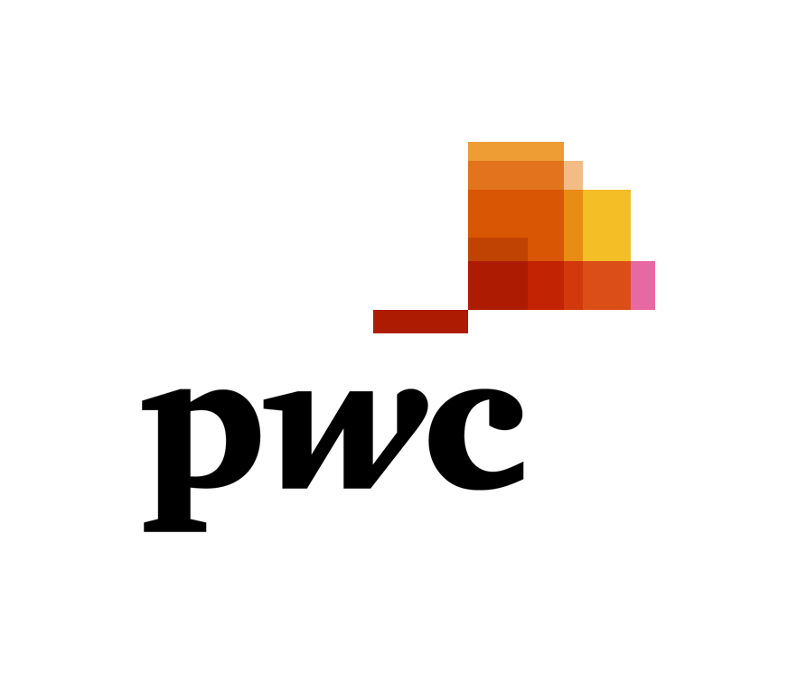

Senior Consultant and Consultant Advisory Services

Are you looking for great career opportunities in the leading professional services company?
Join us as Senior Consultant and Consultant in our Advisory teams and you will quickly get your hands on some exciting work and develop an in-depth understanding of our clients’ businesses and industries.

Job description

What we are looking for:
- Experience in Management Consulting or in an industry role with firmwide exposure; experience in energy (utilities, oil&gas industry), financial institutions, FMCG / retail is preferred;
- Experience in business valuation would be an asset;
- Excellent analytical and problem solving skills;
- Excellent oral and written communication skills, as well as very strong interpersonal skills;
- Ability to work in a team environment with a professional and enthusiastic attitude;
- Ability to learn quickly, be self-motivated, demonstrate initiative and adapt in a dynamic environment;
- Ability to cope with tight deadlines;
- English proficiency.
How to apply:
Please apply no later than 30 November 2018 at: olga.turculet@pwc.com.

