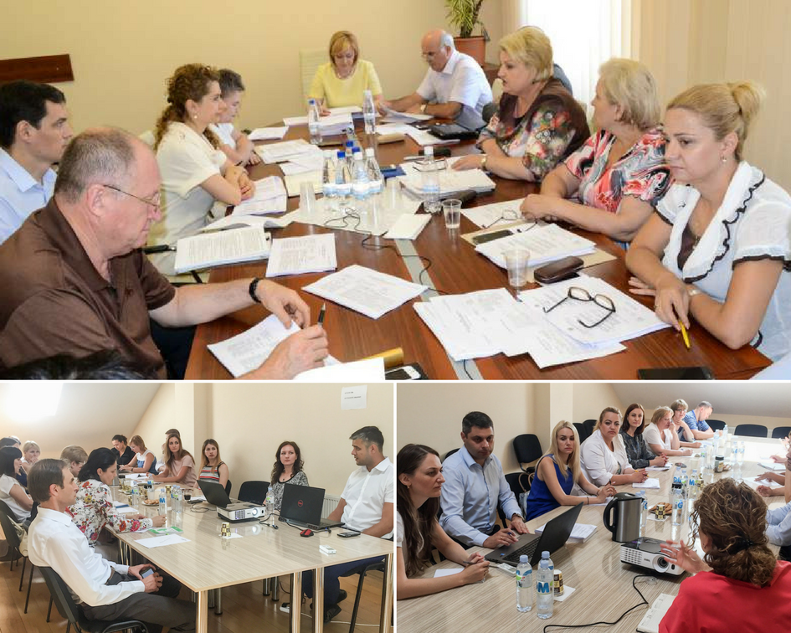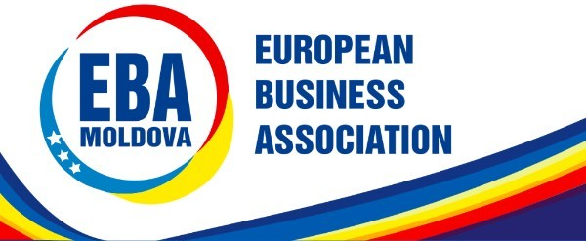EBA Newsletter July 2017 View this email in your browser

EBA BUSINESS ENVIRONMENT

Economic Council to the Prime Minister: Eliminating 5 Salaries Cap
Parliament: Meal Tickets; Labour Code
Ministry of Finance: 2018 Tax Policy; Fixed Assets Management
Competition Council: Competition Law
State Tax Service: Banking Sector Obligations
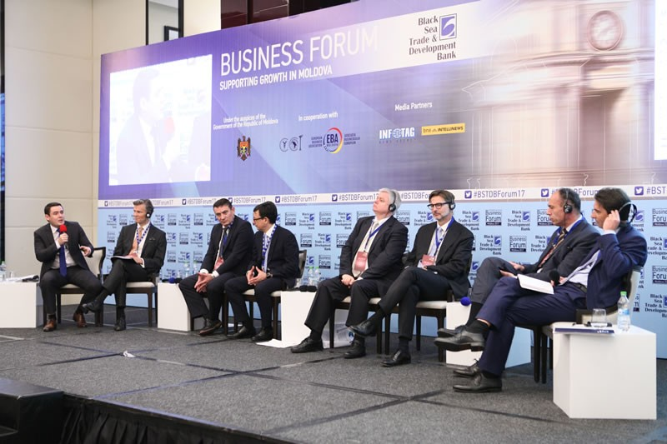EBA BUSINESS SUPPORT

Working Together to Support Growth

More details here
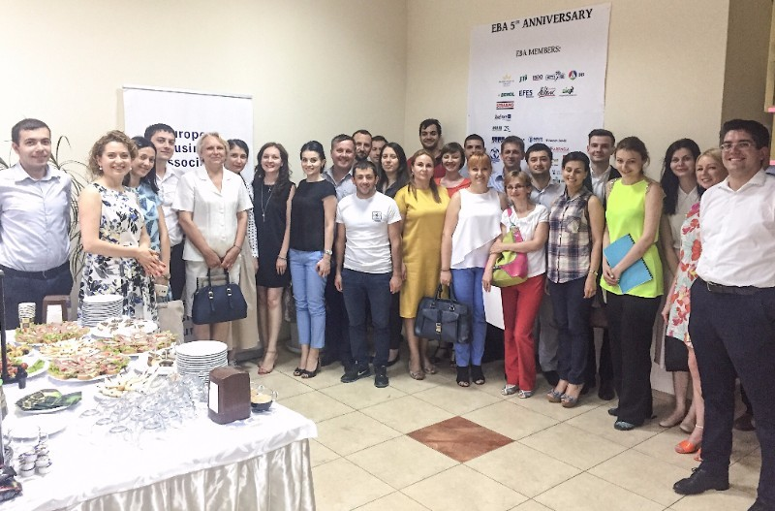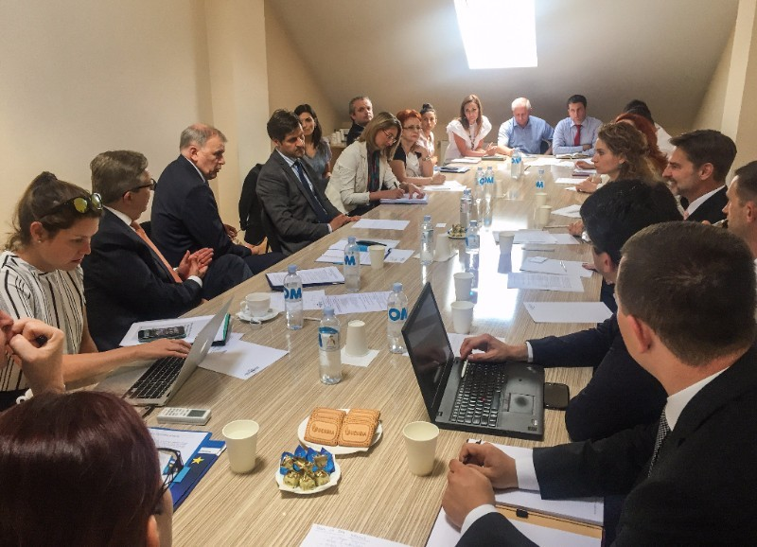

Meeting with the European Commissioner for Health and Food Safety

More details here

Practical Workshop on Regulatory Impact Assessment

More details here

Farewell to Pirkka Tapiola, Honorary President of EBA

More details here

European Business Association Moldova is an independent, non-government organisation, aimed at aligning the national economy and business legislation to the EU standards, and promote European values and best business management practices in the Moldovan entrepreneurial community. The EBA Vision is to enable & drive the full establishment of European business practices and values in Moldova, wishing to promote and contribute to the harmonization of economy of Moldova and the EU.

Contact us:
Phone: +373 22 90 70 25
Email: info@eba.md
Web: www.eba.md
30 Vlaicu Pârcălab str., of. 7,
MD 2012 Chișinău, Republic of Moldova

Copyright © European Business Association, All rights reserved.
Want to change how you receive these emails?
You can update your preferences or unsubscribe from this list

This email was sent to daniela.turcan@eba.md
why did I get this? unsubscribe from this list update subscription preferences
EBA Moldova · 139 ,31 August 1989 str. · Chisinau 2012 · Moldova, Republic of

